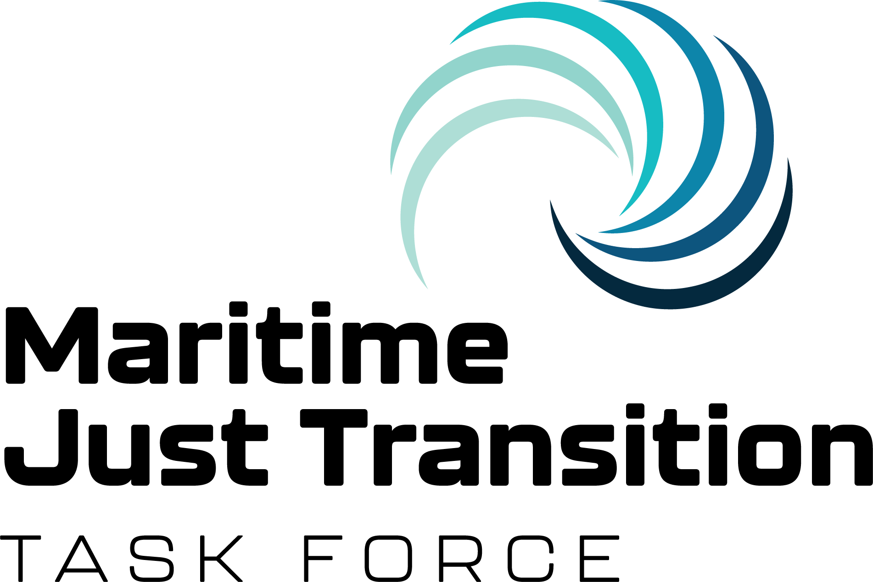

Joint Press Release
UNGC, ICS, ITF

15 February 2023

Africa could be green jobs leader as shipping undergoes low carbon revolution
Experts from the Maritime Just Transition Task Force told Africa’s maritime leaders in Accra today that their continent was well placed to take a large share of the new jobs and training places expected from shipping’s green transition.

Accra, Ghana – Africa has an opportunity to become a world leader in seafarer training and could yet claim many of the new green jobs up for grabs as the global shipping industry transitions to low- and zero-carbon fuels, attendees were told at the Green Shipping Conference held today in Accra today.

The conference is being hosted by the Ghana Maritime Authority in partnership with the Danish Maritime Authority and the UN’s International Maritime Organization (IMO). Delegates, including many Directors-General of shipping, are gathered representing 17 maritime authorities from across the African region. With 1.3 billion people and a combined GDP of $3.5 trillion dollars, Africa is one of the world’s biggest growth markets.

“Many shipowners are already ordering vessels with new designs, powered by alternative fuels and equipped with new technologies. More orders will be made of these new vessels. But the question is: do we have the crew to operate them?” asks Helio Vicente, senior manager of trade policy and employment affairs at global shipowners group, the International Chamber of Shipping.

Research commissioned by the Maritime Just Transition Task Force found as many as 800,000 seafarers could require additional training by the mid-2030s to handle low and zero-carbon fuels such as hydrogen and ammonia if the IMO adopts a target for net zero emissions for shipping by 2050 in line with the 1.5 C goal of the Paris Agreement in July, as many expect it to.

The Task Force experts say as the industry cuts carbon pollution and moves away from fossil fuels to alternative low to zero carbon in anticipation of July’s decision, the training and maritime job opportunities are growing.

Addressing conference delegates, Vicente said, “There is already a shortfall in officers and almost 90,000 additional officers will be needed by 2026. Africa has the opportunity to step up and help provide the world with these seafarers and more, trained with the skills needed for the future.” He said that a future global centre of maritime excellence for seafarer training could be based in Africa, bringing with it more jobs and wider benefits for the region.

“Africa can leverage the strategic opportunities of this shipping revolution. But our advice is that you need to move on this now, today.”

Mohammed Dauda Safiyanu, Africa Regional Secretary for the International Transport Workers’ Federation (ITF) said: “We know that the decarbonisation of shipping, like any transport sector, will only be successful with a Just Transition for its people.”

“Our region, Africa, has an important role in developing the workforce of the future, and also to make sure our African seafarers are properly supported with good quality jobs. To capitalise on this transition, we need to start bringing all parties – governments, employers, and trade unions – together, to align the various training, health and safety, and investment elements. ITF is here to see Africa succeed, and see our continent’s seafarers succeed. Seafarers move the world,” said Safiyanu.

Captain Catherine Haizel, maritime lecturer and seafarer, said: “Governments and employers need to listen to the voice of women seafarers about what we need from a life at sea. I know from many years as a seafarer and as a teacher of maritime studies, that quality training, conditions and benefits make the difference. I see a huge potential for a Just Transition to improve our industry so we can attract more women and more African seafarers.”

Captain Haizel is also ITF inspector for Ghana. She is lecturer at the Regional Maritime University in Ghana and is a member of the Ghana Merchant Navy Officers’ Association.

Sturla Henriksen, Special Advisor, Ocean, UN Global Compact, said: “Moving towards a low-emission global economy will create tens of millions of new, high-quality green jobs across sectors. Through ensuring a Just Transition to a green economy, Africa has an opportunity to capitalize on the emerging green jobs of the future - in shipping and beyond. Governments must now come to the International Maritime Organization this summer and align on an ambitious decarbonization goal of total zero emissions by 2050 with strengthened 2030 and 2040 targets to align to the 1.5ºC of the Paris Agreement. This will help to unlock the investments in seafarer training and skills today to support the green maritime jobs of the future. Small and medium enterprises can play an important role in green job creation, and the UN Global Compact Africa Strategy provides a sustainability roadmap for action.”

The Task Force sees July as an important moment to achieve ambitious consensus and unlock the investment needed to unleash the green maritime jobs of the future.

ENDS
NOTES TO EDITORS:

About the Maritime Just Transition Task Force
The Maritime Just Transition Task Force was established during COP26 in November 2021, by the International Chamber of Shipping (ICS), the International Transport Workers’ Federation (ITF), the United Nations Global Compact, the International Labour Organization (ILO) and the International Maritime Organization (IMO). The Task Force aims to support a just and human-centred decarbonization of the shipping industry. The Task Force is grateful to its primary funder, Lloyd’s Register Foundation, and to its programme partner, the Singapore Maritime Foundation. More information on the Maritime Just Transition Task Force can be found on the UN Global Compact website, the International Chamber of shipping website and the International Transport Workers’ Federation website.

About the Partners
About the UN Global Compact
As a special initiative of the UN Secretary-General, the United Nations Global Compact is a call to companies everywhere to align their operations and strategies with 10 universal principles in the areas of human rights, labour, environment and anti-corruption, and to take action in support of UN goals. With more than +17000 companies and +3800 non business participants based in over 160 countries, and 69 Local Networks, it is the largest corporate sustainability initiative in the world.

About the ITF
The International Transport Workers’ Federation (ITF) is a democratic, affiliate-led federation of transport workers’ unions recognised as the world’s leading transport authority. We fight passionately to improve working lives; connecting trade unions and workers’ networks from 147 countries to secure rights, equality and justice for their members. We are the voice of the almost 20 million women and men who move the world, including over a million seafarers working in domestic trade and international shipping.

About ICS
The International Chamber of Shipping (ICS) is the principal international trade association for merchant shipowners and operators, representing all sectors and trades and over 80% of the world merchant fleet.

MEDIA CONTACTS:
ITF: Rory McCourt media@itf.org.uk +44 (0)7 523 908 679
ICS: Katerina Dimitropoulos comms@ics-shipping.org +44(0) 7497 363434

