Shipping industry calls for release of Galaxy Leader crew still held captive
Today - Monday 19th February 2024 – marks the three-month anniversary since the Houthis seized the Galaxy Leader and its 25 seafarers in the Red Sea. The vessel, a roll-on/roll-off vehicle carrier, was seized on the 19 November. The maritime industry has joined together from around the world to express their concern for the seafarers who have been held hostage and call on the Houthis to release the crew of the Galaxy Leader.
“The 25 seafarers who make up the crew of the Galaxy Leader are innocent victims of the ongoing aggression against world shipping, and their plight is a major concern as the merchant shipping community continues to come under attack.
“All efforts must be made by international organisations and States to secure the release of the seafarers.”
“It is abhorrent that seafarers were seized by military forces and that they have been kept from their families and loved ones for too long. All 25 crew members of the Galaxy Leader must be released now”.
Please kindly see below the full list of co-signatories to this statement.

Asian Shipowners Association (ASA)  Yuichi Sonoda, Secretary General | Asociación de Navieros Españoles (ANAVE)  Elena Seco, Director General
Bahamas Shipowners Association  Domenico Rognoni, Chairman | BIMCO  David Loosley, Secretary General & CEO
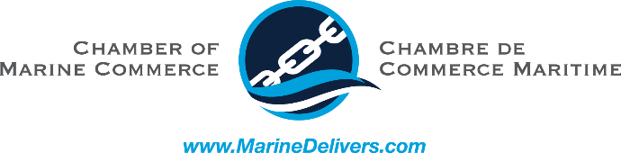  Chamber of Marine Commerce  Bruce Burrows, President & CEO | 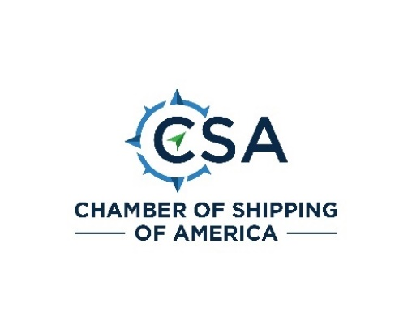  Chamber of Shipping of America  Kathy J Metcalf, President
Confitarma  Mario Zanetti, President | Cruise Lines International Association (CLIA)  Kelly Craighead, President & CEO
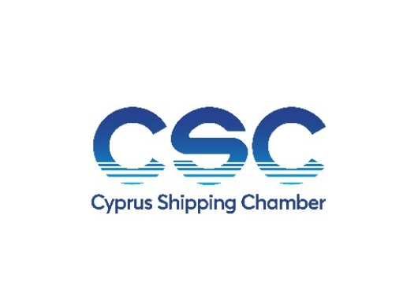  Cyprus Shipping Chamber  Thomas Kazakos, Director General | Danish Shipping  Anne H. Steffensen, Director General & CEO
European Community Shipowners’ Association (ECSA)  Sotiris Raptis, Secretary General | FONASBA (The Federation of National Associations of Ship Brokers and Agents)  Javier Dulce, President
IFSMA  Jim Scorer, Secretary General | 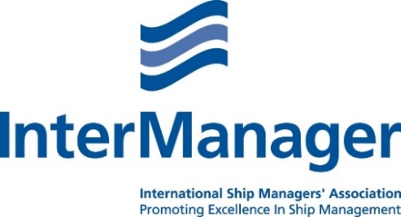  InterManager  Capt. Kuba Szymanski, Secretary General
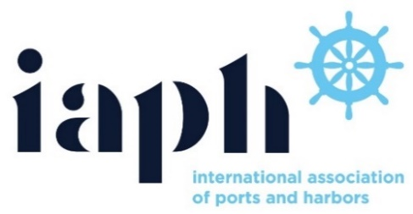  International Association of Ports & Harbors (IAPH)  Patrick Verhoeven, Managing Director | International Chamber of Shipping  Guy Platten, Secretary General
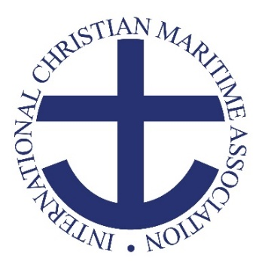  International Christian Maritime Association  Dr. Jason Zuidema, General Secretary | International Marine Contractors Association (IMCA)  Iain Grainger, CEO
International Maritime Employers’ Council (IMEC)  Francesco Gargiulo, Chief Executive Officer | International Parcel Tankers Association (IPTA)  Manish Jain, Chairman
International Transport Workers’ Federation (ITF)  Stephen Cotton, General Secretary | Japanese Shipowners’ Association (JSA)  Toshiya Morishige, Director General
Liberian Shipowners’ Council Ltd (LSC)  Kierstin Del Valle Lachtman, Secretary General | Norwegian Shipowners’ Association (NSA)  Harald Solberg, CEO
Royal Association of Netherlands Shipowners (KVNR)  Annet Koster, Managing Director | 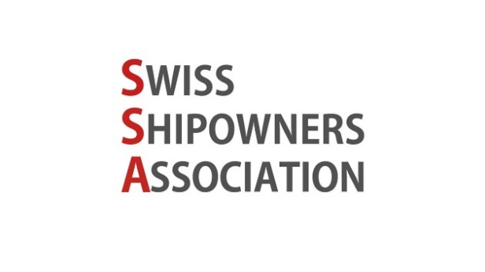  Swiss Shipowners Association (SSA)  Eric André, President
The Seamen’s Church Institute  The Rev. Mark Nestlehutt, President & Executive Director | 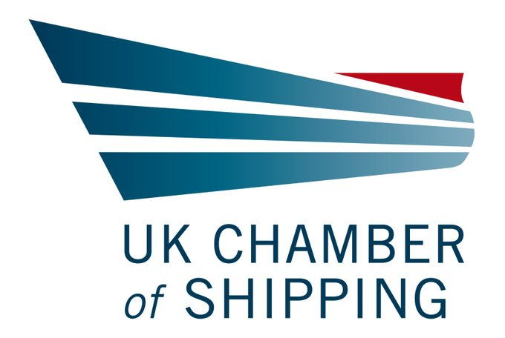  UK Chamber of Shipping  Sarah Treseder, CEO

World Shipping Council (WSC)

John W. Butler, President, and CEO

